Protocol # | Description | Objective | Reqt/Spec | Author
WI-0002 | Lockout on repeated incorrect passwords | To verify user lockout on repeated incorrect password attempts

Prerequisites |  | - Standard System Configuration  - User login exists.  - User must not be signed in (to the Web Interface)  - The value has been set to 8 in database for number of failed attempts.
Procedure |  | - Enter the URL in the browser to bring up the web interface login page.  - Enter a valid test username and password  ER 1 – User is able to login with the correct username and password  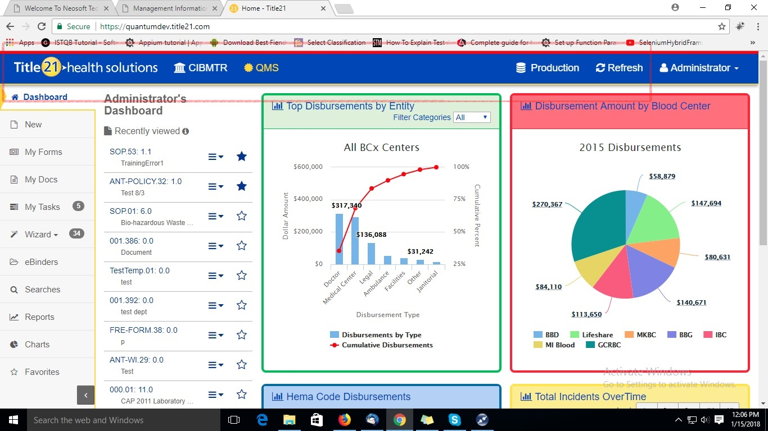  - Log out of the web interface  - Enter the test username with an incorrect password eight times consecutively  ER 2 – On entering the incorrect password eight times the user is locked out and asked to contact the administrator    - Login again, but now with the correct password.  ER 3 – The user remains locked out and cannot login with the correct password  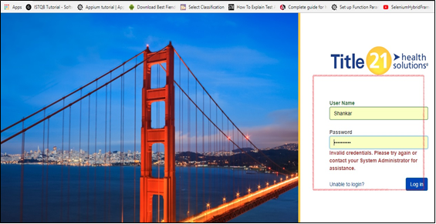
Pass/Fail | Pass:  Fail: |  | Type of Execution:
Pass/Fail |  |  | Automation: | Manual:
 | Date of Execution:
Notes/Deviations
Additional Remarks in case of Manual Execution
Name of Tester(if Manual)
Test Case Review/Approval | Signature of  Reviewer/Approver: |  |  |  | Date of Approval:

